**Value Proposition/Canvas**

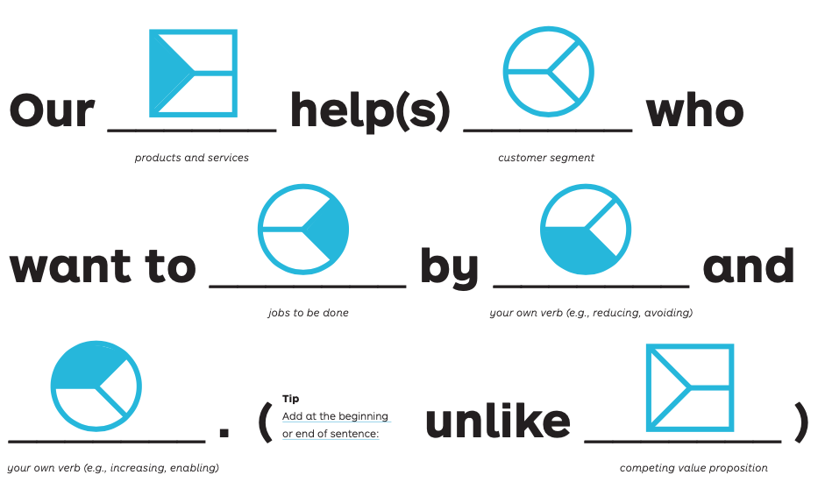

Sources:

NSF i-Corps National Program

Value Proposition Development – [www.Stategyzer.com/VPD](http://www.Stategyzer.com/VPD)

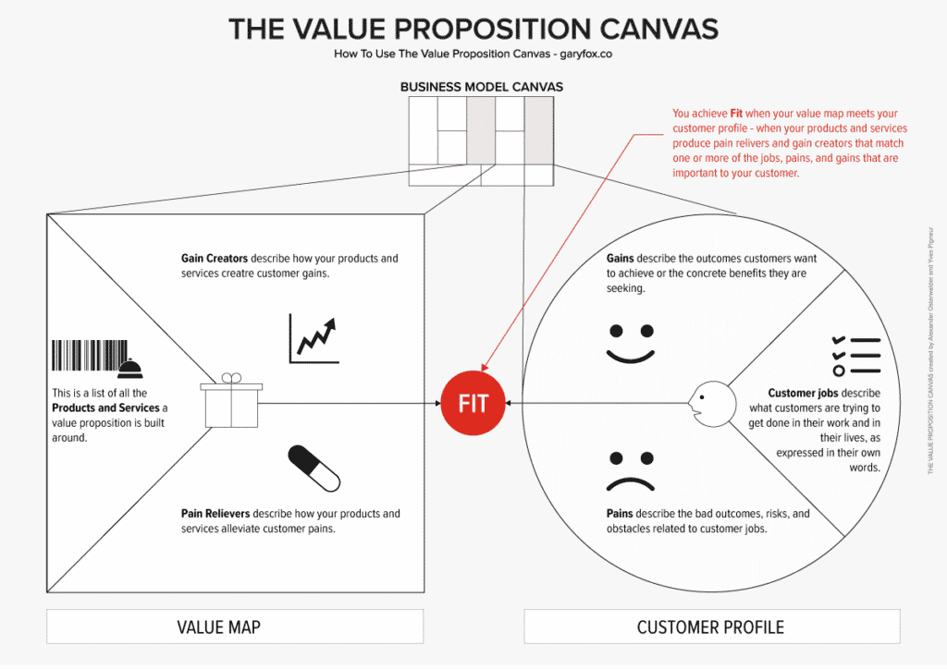

Sources:

<https://www.garyfox.co/canvas-models/value-proposition-canvas-guide/>

<https://www.strategyzer.com/library/the-value-proposition-canvas>